**Instructions for the reviewer:**

1. Please comment on the user/developer guide as a reader, not a teacher. This means that you should point out parts that confuse you, seem strange to you and/or can be enhanced. You do not need to correct or rewrite them but offer suggestions for enhancement.
2. Use the following checklist as a guide and record your comments.
3. Please provide specific and helpful feedback tactfully so that your reviewee can improve on the guides. You can praise what they have done well and offer **suggestions** for improvement. The quality of your comments will count towards your class participation marks.
4. You do not need to correct the grammar, but you should highlight errors and make a note for your reviewee.
5. Re-read your comments to make sure that your comments are clear and understandable before sending this document to the reviewees. Please be ready to provide verbal explanations.
6. **The reviewers should also submit a copy of this document to the LumiNUS submission folder: UGDG Peer Review Forms to obtain class participation marks.**
7. Check with the tutor if you are uncertain about anything.

**Instructions for the reviewee:**

1. Read the reviewers’ comments.
2. Write down whatever questions you may have.
3. When you are both ready, ask the reviewers for clarification on items that seem unclear to you.
4. Thank the reviewers for their help.
5. **Remember: YOU determine how useful this peer review process is. Be responsible and get the feedback and clarification that you need. If your reviewers have not commented on an item and you want feedback, please ask for their opinion.**
6. Revise your UG and DG, so that your testers may be able to use it with minimal effort**.**
7. Submit the final UGDG to CS2101 on Week 13 Friday.

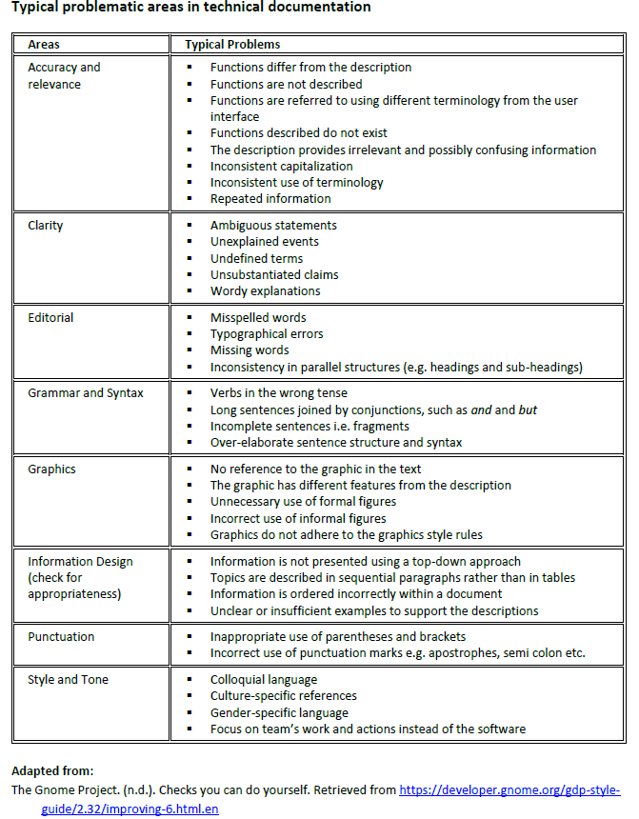

**User Guide Checklist**

**Reviewers:**

**Owners:**

**URL for document under review:**

|  |  |  |  |  |  |
| --- | --- | --- | --- | --- | --- |
| **Criteria** | **Please rate (tick)** | | | | **Remarks** |
| **Excellent** | **Good** | **OK only/Fair** | **Poor** |
| **FRONT MATTERS**   1. Clear and concise user-centric statement of product information (i.e. product description and overview of main features) 2. Clear and concise statement of the purpose of the guide, and the target audience 3. Clear and complete information about how to use the guide (e.g. how to navigate the document, meaning of icons and formatting used) 4. Clear and complete information about how to get started (e.g. installation instructions, operating systems, parts of the GUI, tutorial on how to use CLI) 5. Shows reader consideration by going the extra mile to provide other necessary information, or to make this section welcoming and appealing to the reader |  |  |  |  |  |
| **INSTRUCTIONS for each implementation**   1. Clear and user-centric description of purpose of feature/function/command; 2. Clear and easy-to-follow step-by-step instructions 3. Highly consideration of user needs by providing other relevant and helpful information (e.g. warnings, tips, important note, examples) 4. Clear, relevant, and helpful graphics; visual and/or textual cues are used to indicate which graphic(s) go with which set of instructions 5. Heading, instructions and examples are customized to the application 6. High consideration of user needs by using formatting (e.g. font style, size and colour, mark-ups, callouts, bold, italics) and layout (e.g. white space, alignment) to maximize readability |  |  |  |  |  |
| **PRESENTATION**   1. Consistent and effective formatting (e.g. symbols/icons, font type and size, colours, image size, use of mark-ups and callouts, bullets) and layout (e.g. alignment of text and graphics, white space, paragraphing) throughout the document. 2. Consistent and effective navigation (e.g. provides hyperlinks where necessary or expected, accurate table of contents) 3. Consistent and effective terminology throughout the document |  |  |  |  |  |
| **LANGUAGE, STYLE AND TONE**   1. Consistent user-centric style and tone throughout the document (e.g. you-language, simple but specific words/terms, concise sentences) 2. Consistent and effective phrasing of headings and sub-headings throughout the document 3. Correct grammar, punctuation, spelling, mechanics throughout the document |  |  |  |  |  |
| **OVERALL**  The sections in the guide are highly unified.  The guide leaves the reader with a highly positive impression of the product and the team. |  |  |  |  |  |
| **What other noteworthy aspects of the User Guide have you noticed that deserve commendation?** |  | | | | |

**Developer Guide Checklist**

**Reviewers:**

**Owners:**

**URL for document under review:**

|  |  |  |  |  |  |
| --- | --- | --- | --- | --- | --- |
| **Criteria** | **Please rate (tick)** | | | | **Remarks** |
| **Excellent** | **Good** | **OK only/Fair** | **Poor** |
| **FRONT MATTERS**   * There is a brief description of the software and its functions (e.g. what type of product is it and what it can do for the user). * The purpose of the developer guide is clearly stated. * The target reader is identified and addressed directly. * There is an explanation on how to use the developer guide (e.g. meaning of various formatting conventions, icons, colour codes) |  |  |  |  |  |
| **DESCRIPTION OF SYSTEM DESIGN**   * There is a brief preface to each section to orientate the reader. * Information is organized in a top-down sequence (i.e. starting with the “big picture” before moving to the details). * The document describes how each enhancement is linked to / situated within the overall architecture of the software. * The document describes how the system reacts to user input (where relevant). * The document includes relevant code snippets and UML diagrams. * The UML diagrams are described clearly. |  |  |  |  |  |
| **PRESENTATION AND GRAPHICS**   * Graphics effectively complement the text description. * The reader can easily distinguish the purpose of each graphic and which text it corresponds to. * If graphics are referred to in the text, they are placed after the reference (i.e. text before graphics). * Graphics are labelled appropriately. * Formatting is used correctly, is helpful to the reader, and is consistent throughout the document (e.g. for headings and sub-headings, bullets, graphic labels, colour codes, mark-ups, callouts). * The table of contents is user-friendly. * The layout of the entire developer guide is appealing and user-friendly * Headings and sub-headings are relevant, informative, and concise. |  |  |  |  |  |
| **LANGUAGE, STYLE AND TONE**   * Correct and accurate language is used throughout the developer guide. * Transitional devices are used (where necessary) appropriately to provide coherence to the whole document. * Writing is clear, direct and easy to read. * Writing is concise. There are no repetitive or unnecessary information, descriptions or words. * Style and level of formality are appropriate for the target reader. * Style, formality and tone are suitable and consistent throughout the document. * Level of technicality is suitable for the intended reader/user. |  |  |  |  |  |
| **OVERALL**  The sections in the guide are highly unified.  The guide leaves the reader with a highly positive impression of the product and the team. |  |  |  |  |  |
| **What other noteworthy aspects of the developer’s guide have you noticed that deserve commendation?** |  | | | | |